Dreame Bot D10s Robot Vacuum and Mop
FAQ V1.0

Contents
Contents 1
● General 5
What is the Dreame D10s Robot? 5
What does Dreame D10s feature? 5
What is LDS laser navigation? 6
What is the advantage of the LDS laser navigation? 6
● Product Introduction and User Guide 7
What is the those buttons on the robot vacuum for, and how do I use it? 7
What is meaning of the status indicator in the Auto-Empty Base? 7
How to connect robot with Dreamehome or Dreamehome App? 8
How to reset Wi-Fi with Dreame D10s robot? 1
How to use the Spot Clean function with Dreame D10s robot? 1
How to use the Do-Not-Disturb mode with D10s? 2
How to use the scheduled clean-up feature with Dreame D10s robot? 2
How to save a map with the Dreame D10s robot? 2
How to use the Advanced Map function with the Dreame D10s? 2
How does the D10s clean up the entire house? 2
Can Dreame D10s connect to the Base all the time? Is there overcharge protection? 3
What is the size of Dreame D10s? 3
How long does it take to charge Dreame D10s fully? 4
What battery does the Dreame D10s use？ 4
What is the run-time of the robot vacuum? 4
Does Dreame D10s have a motor overload protection? 4
Does Dreame D10s have any consumables that require maintenance regularly? 4
● Installation and Maintenance 5
How to use the Auto-Empty Base? 5
How to charge the Dreame D10s? 5
How to use the Mopping Function with Dreame D10s? 6
How to remove the water tank with the Dreame D10s? 7
How to start cleaning with the Dreame D10s? 8
How does the Dreame D10s return to the Base for charging? 8
How to clean the main brush of the Dreame D10s? 8
How to clean the dust and filter of the Dreame D10s? 9
How to clean the omnidirectional wheels of the Dreame D10s? 10
How to clean the side brush of the Dreame D10s? 11
How to clean the mop of the Dreame D10s? 11
How to do the routine maintenance for the robot vacuum? 12
How to do the routine maintenance for the Auto-Empty Base? 13
How to replace the Dust Collection Bag 14
How to maintain the battery of Dreame D10s? 15
How should I upgrade the firmware of D10s? 16
How to restore to factory settings with Dreame D10s? 16
● FAQs 16
How to deal with the Wi-Fi network configuration failure? 16
Why does the Dreame D10s fail to charge? 17
What should I pay attention to before cleaning with Dreame D10s? 17
Do I need to charge the D10s for 16 hours for the first three tasks? 17
Why does the robot fail to squirt water or operate with little water during mopping? 17
What should I do if the top cover of the water tank leaks? 18
Do I need to update the firmware whenever there is a new version released? 18
Why does D10s start to clean the next zone before finishing the current one? 18
Why does D10s repeat its cleaning path? 18
Can Dreame D10s clean narrow spaces? 18
Will the cleaning efficacy drop when cleaning a complicated environment? 18
How to reduce the noise during the cleaning? 19
Why does D10s make strange sounds during cleaning? 19
What should I do if the Dreame D10s is trapped during cleaning? 19
What should I do if the Dreame D10s gets stuck when trying to pass through some house furnishings? 19
What should I do if the side brush or main brush is entangled during cleaning? 20
What should I do if the Dreame D10s is entangled with the power cable of the Base? 20
Why does the Dreame D10s fail to relocate itself? 20
What is the max height of obstacles D10s can cross? 20
Why does D10s fail to decelerate when meeting the obstacles? 20
How to deal with device errors of the Dreame D10s? 21
Why does D10s fail to power on? 21
Does D10s consume any power when connected with the Base? 21
Why does the D10s fail to return for charging? 21
Why does the robot keep connecting to the base after returning to charge? 22
Why couldn’t I open the dust bin? 22
How to mop those stubborn stains on the floor? 22
Why is the floor still dirty after mopping? 22
Why do I fail to install the mop pad properly? 22
Why do I smell the odor from the mop and dust compartment? 22
Why does the D10s fail to do schedule clean? 23
Why does D10s fail to resume cleaning after recharging itself? 23
Why does the performance of D10s fade with missed debris on the floor? 23
Can D10s operate in the low-light environment? 23
Why does the D10s fail to upgrade the firmware? 23
Why does Dreamehome/Dreamehome App fail to load the cleaning data？ 23
How to prevent the robot vacuum from cleaning the carpet? 23
Why is the map different than before? What should I do if the map is distorted, inclined, or overlapped? 24
What should I do if the map configuration is not correct? 24
Why is the Carpet Boost function unstable? 24
What should I do if the robot vacuum fails to avoid obstacles during the cleaning? 25
Why does the D10s use a single-sided brush instead of a double-sided brush? 25
Can I use D10s to clean carpets? 26
What should I do if the Dreame D10s gets stuck when trying to pass through a narrow space? 26
Why does D10s fail to reposition itself？ 26
Why does the battery decrease rapidly during cleaning？ 26
Why does D10s fail to return to the Base? 26
How to adjust the humidity of the mop pod？ 27
Why does the D10s fail to avoid some obstacles？ 27
Why does the robot fail to react when operating from the base？ 27
Why does the robot turn off automatically？ 27
Why does Dreamehome/Dreamehome App indicates that the robot is offline？ 27
Why does the robot make a strange noise？ 28

● General

What is the Dreame D10s Robot?

Dreame D9 PRO robot is a smart robot vacuum and mop that can handle sweeping and mopping at the same time in different house types, and return to the dock after cleaning, a powerful tool to make floor cleaning easier.

What does Dreame D10s feature?
Equipped with multiple high-precision motion sensors, Dreame D10s robot also features vision positioning and navigation algorithms to accurately record movements and build maps. Highly adaptive to complicated home environment, the robot can also detect and across obstacles, and return for charging automatically. In terms of cleaning, it uses a front brush for sweeping and a rear wet-pad for mopping. A powerful suction and intelligent water tank are designed for a better cleaning result. Cleaning map is viewable in Dreamehome app at any time, allowing users to set cleaning time, switch operation modes, and clean the whole space with ease.

What is LDS laser navigation?
LDS laser navigation technology measures the relative position of the boundary and the robot vacuum by emitting the invisible laser and receiving reflected light. Based on this, the robot’s position in the map is determined, and a complete cleaning map is built.
The Dreame D10s is equipped with professional lidar sensors, which can scan up to 2,080 points per second with a scanning range of up to 8 m and an accuracy of 10 mm.

What is the advantage of the LDS laser navigation?
The LDS laser navigation is faster in creating the map and more precise in locating than the vSlam. It also supports more map operation options.

● Product Introduction and User Guide

What is the those buttons on the robot vacuum for, and how do I use it?
Please refer to the table below:
Function | Operation
Power/Clean  | · Press and hold for 3 seconds  · Press to begin cleaning after the robot is powered on
Dock/Spot Clean | · Press to send the robot back to the base  · Press and hold for 3 seconds to start Spot Clean Mode
Status Indicator | · Solid White: Cleaning or cleanup is completed  · Blinking Orange: Error  · Breathing White: Robot is charging when the battery  power is not low

How to connect robot with Dreamehome or Dreamehome App?

1. Scan the QR code on the robot, or search " Dreamehome" in the app store to download and install the app.


2. Add Device
Open the Dreamehome app, tap "+" in the upper right, and scan the QR
code above again to add "DreameBot D10s". Please follow the prompts to
finish the Wi-Fi connection.
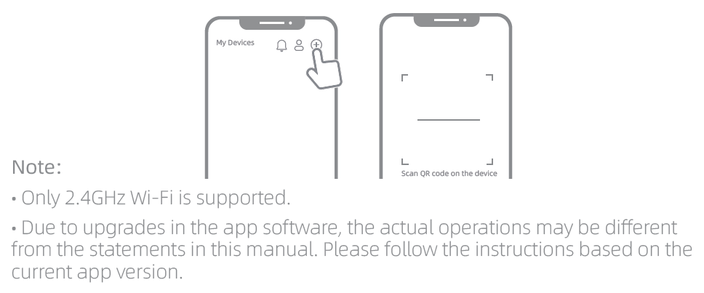

3. Reset Wi-Fi
Simultaneously press and hold the buttons and until you hear a voice
prompt saying, “Waiting for the network configuration.” Once the Wi-Fi
indicator is blinking slowly, the Wi-Fi has been successfully reset.
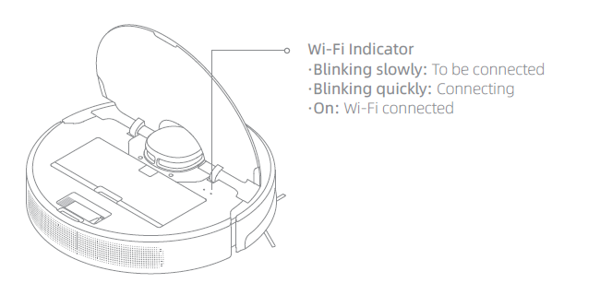
Note: If your robot cannot connect to the app successfully, reset the Wi-Fi and
add the device again.

How to reset Wi-Fi with Dreame D10s robot?
Open the top cover and observe the Wi-Fi indicator LED. Then press and hold the Spot Clean button and Dock button until hearing a voice prompts of "waiting for network configuration.”
When the Wi-Fi indicator starts to flash slowly again, it means the Wi-Fi reset is successful.

How to use the Spot Clean function with Dreame D10s robot?
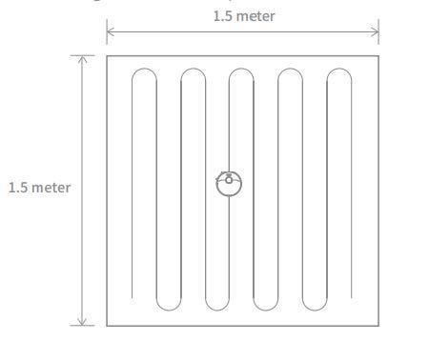
When the robot is paused or in Standby Mode, press and hold the button for 3 seconds to start Spot Clean Mode. In this mode, it will clean a square-shaped area of 1.5×1.5 meters directly around the robot. When the spot cleaning is done, the robot will automatically return to its original location and power off.
Note: Activating Spot Clean Mode will end the current cleaning task of the robot.

How to use the Do-Not-Disturb mode with D10s?
DND mode is enabled by default from 10:00 pm to 08:00 am. You can disable or edit DND mode with the Dreamehome app. D10s will stop cleaning and voice reporting during the DND period, and the power indicator is off.

How to use the scheduled clean-up feature with Dreame D10s robot?
Users can set the schedule clean-up via the APP.
Then, the robot vacuum will automatically start cleaning at the scheduled time and return to the charging base once the cleaning is finished.

How to save a map with the Dreame D10s robot?
When the robot is charging on the Base, launch the Dreamehome app, tap to start cleaning, and D10s will automatically learn about the surrounding environment and build up a complete map after several tasks. Please open all room doors during cleaning to keep the map consistent and complete.

How to use the Advanced Map function with the Dreame D10s?
Launch the Dreamehome app, tap to start cleaning, and D10s will automatically learn about the surroundings and begin building a complete map, where you can access Auto Zone, Area Editor, Zoned Cleanup, Designated Cleanup, Virtual Wall, and other functions.

How does the D10s clean up the entire house?
When started initially, the robot will clean along the edge of an area by 4.5*4.5m, then clean the inner part by S-shape path until covering this area. After the area is clean, it will clean all other rooms in your house by the same principle.
After generating the map, the robot will clean the rooms by the order which edge cleaning first, then S-shape path cleaning until covering all rooms. It is an efficient way to prevent any missed areas.After cleaning, it will return to the Base
automatically.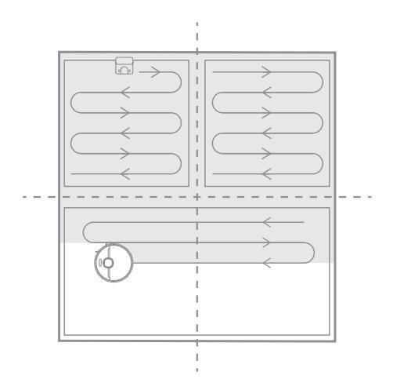

Can Dreame D10s connect to the Base all the time? Is there overcharge protection?
Yes. The robot supports overcharging protection and will disconnect automatically once fully charged.

What is the size of Dreame D10s?
The dimension of the Robot is 350*350*96.8 mm;

How long does it take to charge Dreame D10s fully?
It is about 6 hours

What battery does the Dreame D10s use？
It is a 5200mAh high-performance Li-Po battery pack

Does Dreame D10s have a motor overload protection?
Yes. Dreame D10s has overload protection for all motors on-board, including the suction module, main brush, side brush, and main driving wheel. Motor overload protection is on once the robot is severely clogged with debris or foreign matters.

Does Dreame D10s have any consumables that require maintenance regularly?
Consumables | Suggested Maintenance
Main Brush | Clean weekly and replace every 6-12 months
Filter | Clean weekly and replace every 3-6 months
Side Brush | Clean weekly and replace every 3-6 months
Mop | Wash after the cleaning and replace every 3-6 months

● Installation and Maintenance

How to charge the Dreame D10s?
Press the power button and hold until the power indicator turns solid.
Then place the robot close to the Base, and it will start charging automatically.
Note: Dreame D10s may fail to power on in low battery. Please place the Robot directly to the Base.

How to use the Mopping Function with Dreame D10s?
It is recommended that all floors are vacuumed at least three times before the first mopping session to achieve a better cleaning effect.
1) Dampen the mop pad and wring out excess water. Insert the mop pad into the slot of the water tank as shown in the figure, and paste the pad firmly.
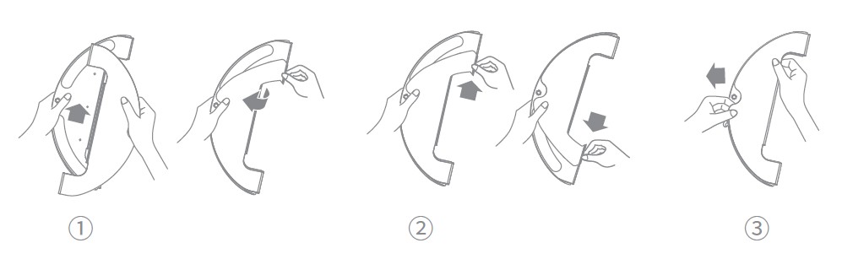
2) Open the water tank lid, fill the tank with water, then securely close the lid.
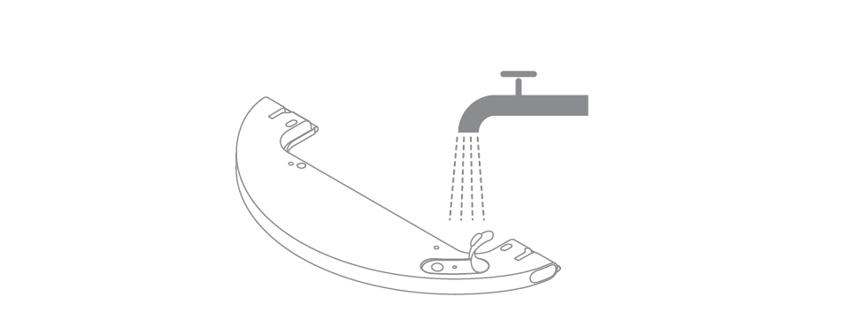
Note: Do not use detergent or disinfectant.
3) Align the mopping module as indicated by the arrow, then slide it into
the back of the robot until it clicks into place. Press the button or use the
Dreamehome or Dreamehome/XiaoDreamehome app to start cleaning.
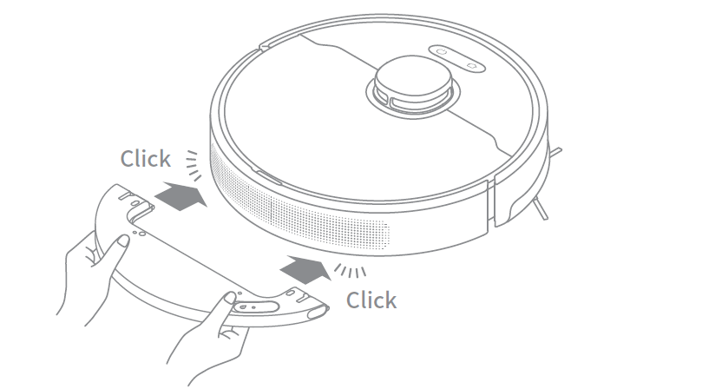
Note:
• It is not recommended to use the mopping function on carpets.
• Use the app to adjust the water flow as required.
4) Press the two side clips inwards and slide the water tank backwards to
separate it from the robot.
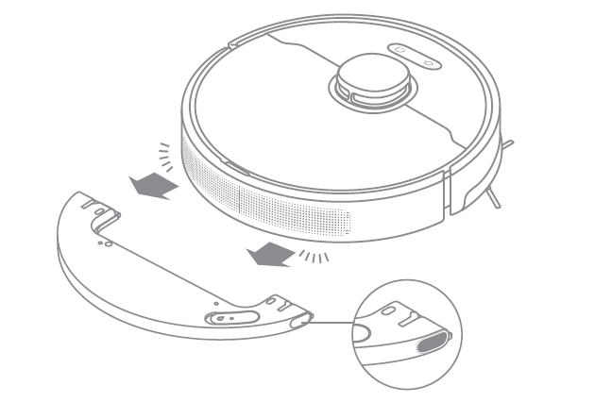
Note: When the robot is charging or not in use, remove the mopping module,
pour out all the remaining water in the tank, and clean the mop pad to prevent
mildew or odors.

How to remove the water tank with the Dreame D10s?
Press the two side clips inwards and slide the water tank backward to separate it from the robot.

How to start cleaning with the Dreame D10s?
Press the power button, it will start cleaning.
Press any button during the cleaning, and it will pause.
Note: Dreame D10s will fail to work when the battery is too low. Please charge before using.
If the completed cleaning duration is less than 10 minutes, the Dreame D10s will do the cleaning twice by default.

How does the Dreame D10s return to the Base for charging?
After the cleaning, the Robot will return to the Base for charging automatically.
Press the Dock button when the Robot is under Pause status.
When the Robot is charging, the power button will flash in colors: battery>15% with White and battery <15% with Orange.

How to clean the main brush of the Dreame D10s?
1. Face the bottom of D10s up, press the buckle to remove the main brush protector.
2.Take out the main brush by pulling upward and clean the bearing.
Remove the end cover at both sides of the main brush to clean the tangled hair.
3.Cut off the tangled hair on the main brush with the cleaning tool in the box.
4.Install the main brush and press the buckles to fix the protector.
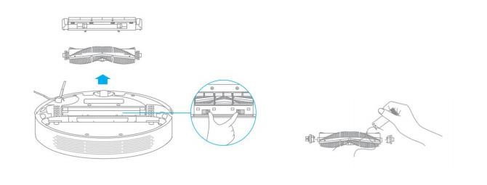
Note: It is recommended to clean the main brush every week and replace it every 6-12 months for better cleaning performance.

How to clean the dust and filter of the Dreame D10s?
A:（1）Open the upper cover of the robot, press the buckle to remove the dust bin;
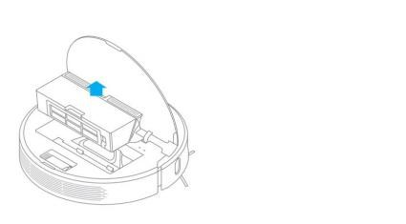
Open the bin cover marked with the arrow and remove the debris inside;
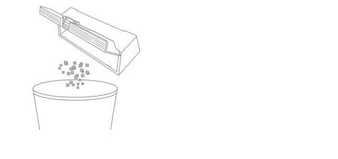
Fill th dust bin with water, close the cover, shake the bin left and right, pour out, and repeat for several times;
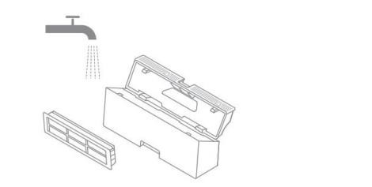
Note: Wash the dust bin with water only. Do not add any detergent or clean the filter screen with a finger or brush.
Remove the filter screen as illustrated, spin off the water, dry the filter before installing it back to the bin for use.

Note: Ensure the filter is dried up (for at least 24 hours) before use.

How to clean the omnidirectional wheels of the Dreame D10s?
1.Turn the robot over and pull the wheels upward.
2.Clean the hair and dirt on the wheels and axles.
3.Re-install the wheels by pressing them firmly down.
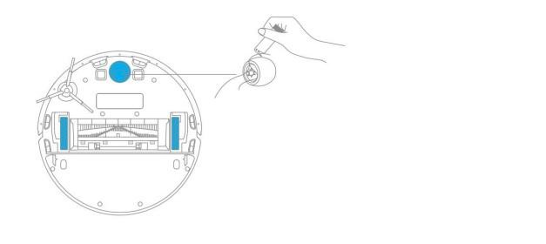
Note: Wheels can be rinsed with running water. Make sure to dry up before use.

How to clean the side brush of the Dreame D10s?
1. Turn over the robot, pull out the side brush and clean it up as shown below.
2.Re-install the side brush.
Tip: It is recommended to clean the side brush once a month and replace it every 3-6 months for better clean performance.
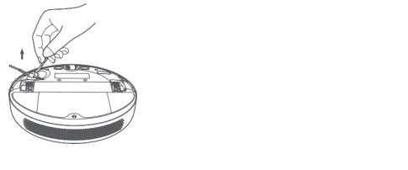

How to clean the mop of the Dreame D10s?
1. Press the two release clips on the side of the water tank, remove the
mopping module, and pull the mop pad off the mopping module.
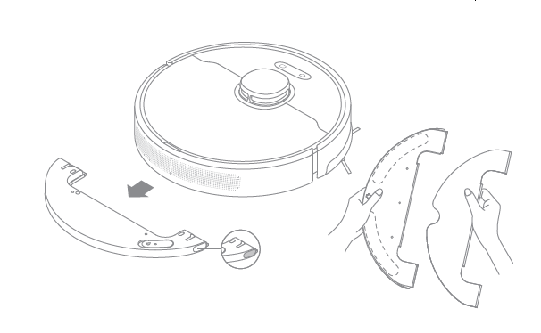
2. Pour out the water in the tank. Clean with only water and leave out to air dry before re-installing.

Note: Do not expose the tank to the sun directly.
3. Clean the mop pad with water only and leave to air dry before re-installing.
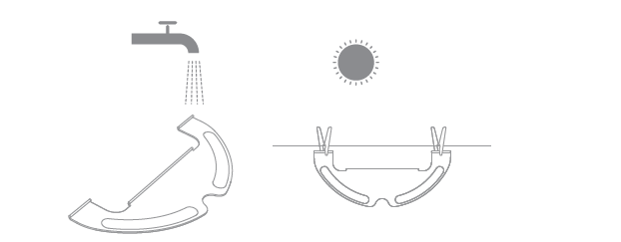
Note:
• Remove the pad from the mopping module before cleaning it, and make sure
dirty water does not flow back into the water outlet to avoid clogging.
• For optimal performance, it is recommended to replace the mop pad every 3-6
months.
4. If slow water flow occurs, or the volume is not well-distributed, clean the air hole in the cover of the water tank.


How to do the routine maintenance for the robot vacuum?
Use soft dry cloth to wipe the parts, which includes:
1.Four cliff sensors at the bottom
2.The infrared deceleration sensor in the front
3.The electric pole at the bottom
4.Motion tracking sensor at the bottom
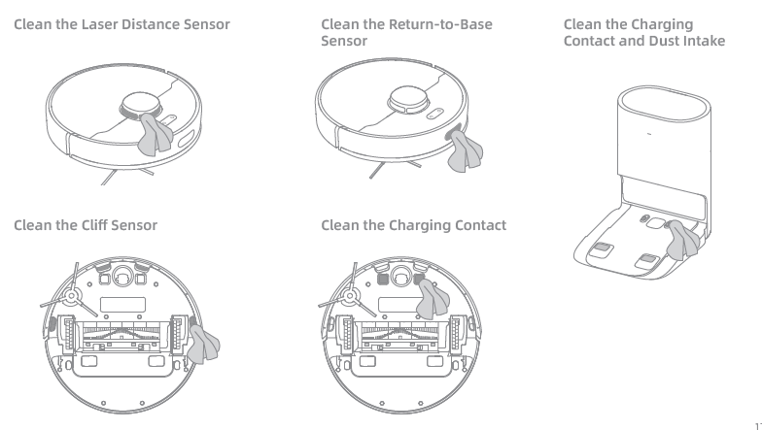

How to maintain the battery of Dreame D10s?
The robot contains a high-performance lithium-ion battery pack. Please
ensure that it remains well-charged for daily use to maintain optimal
battery performance. If the robot is not used for an extended period of
time, turn it off and put it away. To prevent damage from over-discharging,the robot should be recharged at least once every three months.

How should I upgrade the firmware of D10s?
It can be done by Dreamehome or Dreamehome APP(please make sure the D10s is on the Base and the battery is over 15%).
Two buttons on the D10s will flash rapidly during the Whole process.

How to restore to factory settings with Dreame D10s?
A: If D10s still fails to operate normally after restarting, press and hold the reset button with a tool until hearing the voice prompt “start to restore factory settings.”
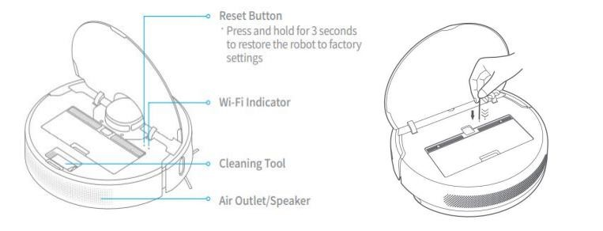

● FAQs

How to deal with the Wi-Fi network configuration failure?
The Dreame D10s only supports the 2.4G Wi-Fi network. It could not work with the 5G Wi-Fi network. Please check below:
1.Confirm both the Robot and the mobile phone are close to the Wi-Fi router with strong Wi-Fi signals.
2.When connecting to the Hotspot of the Dreame D10s, please kindly return to the
app to wait for the configuration result until hearing the voice prompt.
3.Enable the Location permission settings for the App. If not, the connection will fail.
4.If the configuration still fails, please reboot the router and the robot.
For further assistance required, please kindly contact the Dreame Support Team.

Why does the Dreame D10s fail to charge?
Please clean the charging interface of the Base and the robot if there is any dust on it, as dust may result in charging failure.

What should I pay attention to before cleaning with Dreame D10s?
Make sure the D10s is fully charged before cleaning. Tidy up the space, put away fragile items and objects on the floor before cleaning.

Do I need to charge the D10s for 16 hours for the first three tasks?
it is not required,please do the normal charging.

Why does the robot fail to squirt water or operate with little water during mopping?
Check the current water level in the water tank, install the mop properly according to instructions, and clean the mop in time.
Before mopping, please wet the pad for a better mopping experience before the robot squirts water.
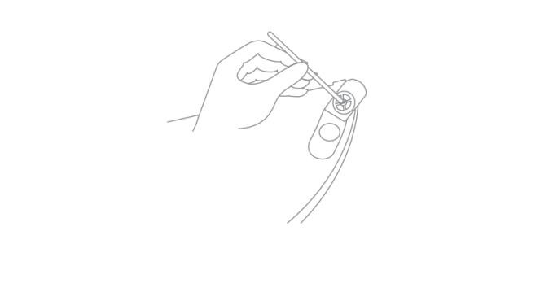

What should I do if the top cover of the water tank leaks?
The top cover of the water tank has a vent hole to balance the air pressure inside and outside the water tank. After filling water, level the water tank level during installation. Slight leakage is normal if the water tank is tilted during removing and installing.

Do I need to update the firmware whenever there is a new version released?
Each new firmware update is an optimization. Please update in time to ensure the best cleaning experience.

Why does D10s start to clean the next zone before finishing the current one?
After the first mapping, Dreame D10s will clean your home by room. If this issue occurs, check the zone settings in the app and adjust the settings if any errors arise.

Why does D10s repeat its cleaning path?
Dreame D10s will follow the most effective cleaning path to clean your home. It may look repetitive when the robot navigates itself from the cleaned area to an uncleaned one, but it is not repeating the work.

Will the cleaning efficacy drop when cleaning a complicated environment?
The Dreame D10s will clean all corners in your home to ensure complete coverage. D10s turns to make more turns and vacuums along the edges in a complex environment, resulting in decreased efficiency.

How to reduce the noise during the cleaning?
Check if the brush is stuck with objects and clean it in time to avoid any damage caused.
To reduce the noise, kindly choose the quieter mode.

Why does D10s make strange sounds during cleaning?
When cleaning on tile or wood floor, D10s may produce a slight sound when its bottom rubs on the floor. The D10s will clean and sweep the joins on the floor as it passes through, which may produce a slight rattling sound. These are all normal sounds and will not affect cleaning results.

What should I do if the Dreame D10s is trapped during cleaning?
When cleaning, the D10s may get stuck by slippers, plastic bags, and other clutters. Remove the clutters and put D10s back to the cleaned area close to the interrupted point. Please clean up clutters on the floor to prevent the robot from getting stuck during cleaning.

What should I do if the Dreame D10s gets stuck when trying to pass through some house furnishings?
During the Cleaning, if the robot meets the bottom of the furniture, which has a similar height to the robot, it may get stuck.
Please kindly purchase the magnetic stripes to avoid this issue. If not, please place some obstacles at the bottom of the furniture to prevent the robot from entering again.

What should I do if the side brush or main brush is entangled during cleaning?
When cleaning, the side brush and main brush may be entangled by power cords or charging cables on the floor.
Please try to place the host in the cleaned area nearby to continue cleaning after tidying up the cables.
Please clean up clutters on the floor to prevent the robot from tangling during cleaning.

What should I do if the Dreame D10s is entangled with the power cable of the Base?
Please tie the excessive power cord of the Base with a strap before cleaning. Do not put it on the floor.

Why does the Dreame D10s fail to relocate itself?
Moving the D10s to an uncleaned area will cause repositioning failure. Ensure D10s is moved to a cleaned area.
If a person is standing next to the D10s, it will fail to reposition itself.
Do not stand next to D10s and ensure the camera has full access to all feature points in the room.
D10s may fail to reposition itself in low lights. Please ensure sufficient light for repositioning.

What is the max height of obstacles D10s can cross?
The D10s can cross obstacles up to 20mm high, shorter with the water tank installed. The max obstacle height will also decrease when D10s is working on the slippery floor.

Why does D10s fail to decelerate when meeting the obstacles?
With the LDS Sensor, the D10s could detect the obstacles and decelerate.
However, for dark table legs or short barriers, it might be unable to detect and decelerate.

How to deal with device errors of the Dreame D10s?
Press the Power/Clean button and hold for 6 seconds to reboot.

Why does D10s fail to power on?
D10s cannot be powered on in low battery. Please connect the D10s to the Base and confirm the working temperature is in the range from 0 to 50℃.

Does D10s consume any power when connected with the Base?
When connecting with the Base, the D10s is powered by the Base, while the builtin battery of the D10s will enter sleep mode with minimum power consumption to keep itself in the best performance.

Why does the D10s fail to return for charging?
Check if there are too many obstacles around the Base. Please keep both sides of the base at least 0.5m away from the obstacles and make sure there are no obstacles 1.5m above the base.
1.If D10s does not start from the Base for cleaning, it may fail to find the Base
2.after finishing up. Please ensure the Robot starts cleaning from the Base.
3.Moving D10s to an uncleaned area will cause repositioning failure. In this case, restart the task.

Why does the robot keep connecting to the base after returning to charge?
Please check whether the charging interfaces of the base and the robot are with dust. Please clean the dust before using the system.

Why couldn’t I open the dust bin?
Please refer to the marking on the cover to open the dust bin correctly. Do not open the dust bin by removing the filter.

How to mop those stubborn stains on the floor?
The D10s may not be able to remove some stubborn stains on the floor while mopping. Please clean them manually.

Why is the floor still dirty after mopping?
Wash the mop pad in time when mopping on the dirty floor.

Why do I fail to install the mop pad properly?
Align the mop pad with the module before installation.
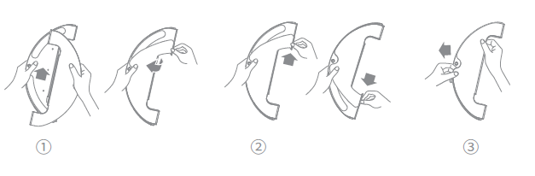

Why do I smell the odor from the mop and dust compartment?
Odor is caused by the dirty mop that is not washed in time after cleaning. Please clean the rag in time after mopping the floor. The dust bin may also emit odor with liquid getting inside. Please clean the dust bin in time after cleaning.

Why does the D10s fail to do schedule clean?
It might be caused by the low battery level. The scheduled clean only works when the battery level is higher than 15%.

Why does D10s fail to resume cleaning after recharging itself?
Make sure the D10s is not working in the DND Mode. If you actively command it to return or manually move it back to the dock, D10s will not resume cleaning either.

Why does the performance of D10s fade with missed debris on the floor?
Clean the dust bin if it is full; Clean the filter clogged with dust; Clean the main brush if it is tangled with foreign matters.

Can D10s operate in the low-light environment?
Yes, it could.

Why does the D10s fail to upgrade the firmware?
Please kindly check the network connection and do the firmware upgrade with a stable network connection.
Please make sure the battery is over 15% before upgrading.

Why does Dreamehome App fail to load the cleaning data？
Check the network connection; Restart the app, and try again.

How to prevent the robot vacuum from cleaning the carpet?
Set the No-Go Zone around the carpet via the APP, and the robot vacuum will avoid the carpet while cleaning.

Why is the map different than before? What should I do if the map is distorted, inclined, or overlapped?
The map is distorted or overlapped:
Make sure the map is saved successfully, which means the parted sections are shown in the map, and the area cleaning can work properly.
Turn off the power and restart the robot vacuum. Then manually place the robot vacuum to the charging base and try to restore the map. If the restoration fails, replace the charging base position and redo the mapping.
Recommendations:
1.Properly place the base against the wall by making sure the open space beside the base should be at least 0.5m, and there are no obstacles 1m from the front of the base.
2.While the robot vacuum is working, please do not manually move the machine.
3.Strong light or highly reflective situations might cause the malfunction of the mapping.
4.We recommend closing the curtain or finding another time when the light is not so strong to clean. For highly reflective surfaces, it’s better to cover 15cm from the bottom of the surface while cleaning.
Users can reset the mapping, and the robot will remap during its next cleaning.
5. Regularly check and clean the navigation sensors with a soft cloth or tissue.

What should I do if the map configuration is not correct?
We could adjust the Map manually via the App.

Why is the Carpet Boost function unstable?
This function is still the beta version. Using the robot on the shorter carpet might cause the function failure.

What should I do if the robot vacuum fails to avoid obstacles during the cleaning?
1. Wipe the LDS sensor with a soft dry cloth and try to restart the device to check if it can work properly. The sensor might be clouded by dirt.
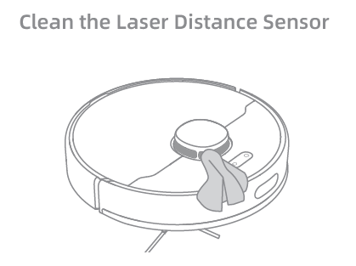
2.If the robot vacuum is connected to the network and is online, open the APP and click … on the upper right corner to check if the obstacle avoidance is off. Switch it on if it is off and restart the machine to check if it can work properly.
3.Make sure if the APP has the latest version. We suggest keeping the APP up to date ensure a better cleaning experience.

Why does the D10s use a single-sided brush instead of a double-sided brush?
The D10s uses a single-side brush + main brush for cleaning. The single-side brush is mainly responsible for cleaning the garbage near the walls and furniture edges. Compared with the double-sided brush, it is easy to blow up the garbage when cleaning, and the double-sided brush is more likely to be entangled on the carpet.

Can I use D10s to clean carpets?
The D10s can clean some medium and short-pile carpets. Carpets that are too long are more likely to be sucked into the dust box, and the side brushes and drive wheels are easy to get stuck. At the same time, it is recommended that you set up "sweeping restricted area"/"sweeping restricted area" to avoid wetting the carpet.

What should I do if the Dreame D10s gets stuck when trying to pass through a narrow space?
D10s may get stuck when it tries to clean a narrow space, for example, the bottom of a closet that is close to its height. Magnetic stripes are provided to help set a virtual wall or you can block the narrow space with an obstacle to prevent D10s from entering.、

Why does D10s fail to reposition itself？
Moving D10s to an uncleaned area will cause repositioning failure. Ensure D10s is moved to a cleaned area.
If a person is standing next to the D10s, it will fail to reposition itself.
Do not stand next to D10s and ensure the camera has full access to all feature points in the room.
D10s may fail to reposition itself in low lights. Please ensure sufficient light for repositioning.

Why does the battery decrease rapidly during cleaning？
After D10s is charged and stored for a long time, it is normal for the battery to drop quickly in the first few minutes during cleaning. After this, the power consumption will return to normal. The battery will also drop faster in Turbo mode.

Why does D10s fail to return to the Base?
1.Check if there are too many obstacles around the Base. Put the Base in an open area free of obstacles within 0.5 m on both sides and 1.5 meters in front of the Base.
2.If D10s does not start from the Base for cleaning, it may fail to find the Base after finishing up. Therefore, please ensure D10s starts cleaning from the Base.
3.Moving D10s to an uncleaned area will cause repositioning failure. In this case, restart the task.

How to adjust the humidity of the mop pod？
Launch the device via Dreamehome App and adjust the humidity of the mop pod in cleaning mode.

Why does the D10s fail to avoid some obstacles？
To improve the cleaning performance, it is suggested to clean items such as threads/rags/slippers on the floor in advance.

Why does the robot fail to react when operating from the base？
When the robot is too far from the base, it will lose the connection. It will automatically connect back when the signal strength is stable.

Why does the robot turn off automatically？
The robot will turn off automatically when the battery is less than 2% or when it is not charging and has no operations in 12 hours.

Why does Dreamehome/Dreamehome App indicates that the robot is offline？
Please make sure the robot is turned on and the Wi-Fi connection is stable. During the cleaning, the robot might be offline when the Wi-Fi network connection is weak in some areas. It will be back online automatically when the Wi-Fi signal is strong.

Why does the robot make a strange noise？
The main brush, side brush, or main wheels may be entangled with hair or debris. Turn off the robot and clean it.

